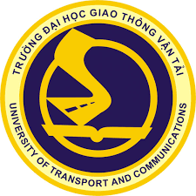 | 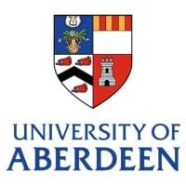 | 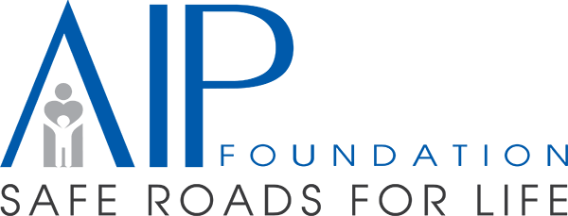 | 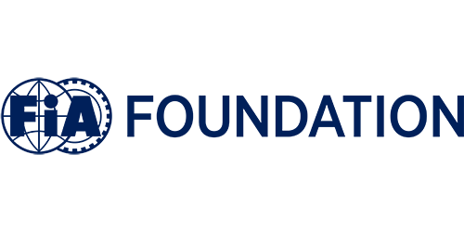 | 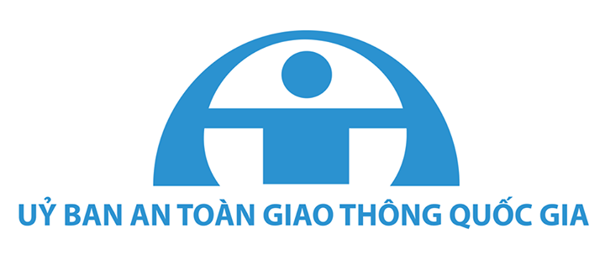
Project: Cross-Sector Partnerships to Improve Transnational Education and Gender Equity in Transport sector in Vietnam (GGPVN2.5)
PROJECT KICK-OFF MEETING
Event details
- Time: 16.00 – 17.00 (Viet Nam time)/09.00 – 10.00 (UK time)
- Date: Wednesday, 16 February 2022
- Platform: online on Google Meet at https://meet.google.com/sit-acmk-wye
Aims
- Sharing the project summaries including aims, deliverables, expected outcomes, impacts, main activities and key milestones of the project.
- Introducing project team members in the consortium.
Participants
Participants will include:
- British Council
- University of Transport and Communications
- University of Aberdeen
- AIP Foundation
- FIA Foundation
- National Traffic Safety Committee
Tentative agenda:
Viet Nam time | UK time | Agenda | Speaker
16.00 | 09.00 | Welcome speech and general introduction | Hieu Ha, UTC
16.05 | 09.05 | British Council representative sharing view about expected impacts on HE development of the GGPVN2.5 project | British Council representative
16.10 | 09.10 | Key members sharing background and experience, contribution to the project and introducing project team
16.10 | 09.10 | University of Transport and Communications | UTC representative
16.15 | 09.15 | University of Aberdeen | UoA representative
16.20 | 09.15 | AIP Foundation | AIPF representative
16.25 | 09.25 | FIA Foundation | FIAF representative
16.30 | 09.30 | Project presentation including aims, deliverables, expected outcomes, main activities and key milestones | Hieu Ha, UTC
16.45 | 09.45 | Discussion
16.55 | 09.55 | Summary and take photo
17.00 | 10.00 | End

